Building stress resilience in early adolescents’ lives (BReal)
Worksheet: Lesson 1 “Born to be brave”
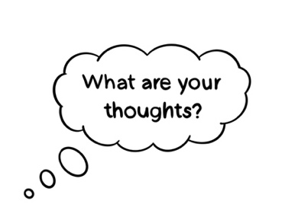

Lesson 1 Baseline: Student Questionnaire
By yourself, indicate to what extent you agree with each of the statements by ticking or circling the corresponding box on the grid. Your answers should reflect your honest opinion about each statement.
Statement 1: “Stress is always bad” | Strongly disagree | Disagree | Undecided | Agree | Strongly agree
Statement 2: “mistakes are always bad” | Strongly disagree | Disagree | Undecided | Agree | Strongly agree

Question 3: What makes people feel stressed? Give examples:

Question 4: A friend is feeling stressed and worried about a test. What could they do that would help? Fill in 3 ideas in the thought bubbles below:
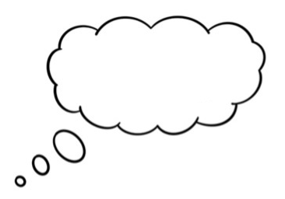


Case studies
Kai is in Year 7. Since starting secondary school, he has found it hard to get organised. He forgets to bring things into school and get his homework done on time. He also loses things, like his PE kit. Kai has dyslexia. He can find it difficult to read long and complicated instructions and can find it hard to remember things. On a Sunday evening, he often starts to worry about the week ahead, his stomach and head hurt, and he finds it hard to sleep. He worries about getting into trouble. Sometimes he feels like a failure and can’t think of anything good about himself. He often feels a bit down and feels like nothing is any fun.

Maryam is in Year 7. She is fairly quiet in class. She doesn’t always find schoolwork easy, but really tries to give things a go and not to give up. Maryam has recently started to learn to play the saxophone. Every time she practices at home, her brother covers his ears and tells her how bad it sounds. However, if anyone says she can’t do something, she sees this as a challenge, and it makes her even more determined to do it. She’s given herself a goal of being able to play ‘Jingle Bells’ in time for Christmas and is trying to practice for 5 minutes each day. Sometimes this is hard, and she feels she isn’t making much progress, but she’s keeping going.

Joe is in Year 7. He has been best friends with Maisie since primary school. He was pleased (and relieved) when he was put in the same form as Maisie at secondary school. Joe has begun to feel worried that Maisie doesn’t want to be his friend anymore. He feels that Maisie isn’t talking to him as much and is leaving him out of chats and activities with other people. He has tried telling Maisie how much this upsets him, but this just seems to cause arguments. He has suggested that they spend more time together just the two of them. He feels like he can’t do anything right and just wants his old friend back.

Amber is in Year 8. She is well-liked and has a couple of close friends. However, she worries a lot about friendships and what other people think of her. She is worried about looking ‘stupid’ or ‘weird’ in front of other people. She finds non-uniform days stressful, spending ages thinking about what she might wear and worrying about whether other people might laugh at her outfit or talk about her behind her back. Amber really enjoys singing and dancing and would really like to audition to be in the school production but is really worried about messing up and what other people would think if she didn’t get a part.

Tia is in Year 8. She loves athletics and playing football. She does sport at school and plays football for a local club. Tia is small for her age and some of the girls she plays football with are now quite a bit taller and stronger than her. Sometimes this makes it hard for her to out-run them or get the ball in a tackle. Recently Tia hasn’t been picked for the first team and has been substituted in a game, which has been frustrating - she has wondered whether she should just give up playing. The other evening, she couldn’t face going to football and instead said to her mum that she felt too ill to go.

Harry is in Year 8. He mostly does well at school and often puts his hand up in class to answer questions. Recently his teachers have noticed that he finds it hard to take feedback and often seems to give up and start messing about if he doesn’t understand something the first time around. For Harry, seeing himself as clever means that when he can’t get something right first time, he gets frustrated. He feels it should be easy for him to do everything.

Personal Reflection

Practise Makes Progress

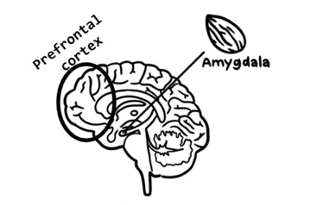
When you notice stressful feelings in yourself, can you try to go outside your comfort zone, and rather than avoid things you are stressed about, be brave and try and face them instead?

Practice will strengthen the connections between brain regions that help manage and control stress response (the prefrontal cortex) and the brain regions that respond to stress (amygdala).

Try to fill in the table below with a few examples from your experiences in the last few weeks, to track your emotions and body's response. You do not need to share your responses with your teacher or classmates, this is just for your own reflection.

Date/  Time | What were you stressed about? | How did you feel? | What was happening in your body? | What did you do? | How did it go?  /What happened next?
Wed,  8am | Realised I hadn’t done my homework that was due in that day | Scared and cross | My heart was beating fast, felt shaky and sick and that I was going to throw up | Instead of focusing on how bad I was feeling, I managed to do it quickly before I left for school |  | It was ok but I realised that I need to be more organised in the future

Key messages of Lesson 1
1. Stress isn't always bad.
2. Everyone can learn to manage stress.
3. Recognising stress and challenging ourselves to try new things can help us learn to manage stress well.
4. Learning to manage stress can make us and our brains stronger.

